DIGITAL IC APPLICATIONS

Combinational circuits USING VHDL PROGRAMMING
HAND NOTES

BY:
P.RAJESH _{M.TECH.,}
ASST PROF
CRIT COLLEGE OF ENGG
RACHANAPALLI
ANANTAPUR-515001
PH:- 09989786119
EMAIL:- rajesh.crit@gmail.com

Contents:
- Introduction
- Adders
  - Half Adder
  - Full Adder
    - Full Adder using AND-OR
    - Full Adder using AND-OR
  - n-bit Carry Ripple Adder
    - 4-bit Carry Ripple Adder
  - Larger Adder
    - Carry Look-Ahead Adder
  - BCD Adder
- Subtracter
  - Half Subtracter
  - Full Subtracter
  - Parallel Binary Subtracter
  - Serial Binary Subtracter
- Comparators
- Multipliers
- Dividers
- Parity Circuit

Introduction

Arithmetic circuits are the ones which perform arithmetic operations like addition, subtraction, multiplication, division, parity calculation. Most of the time, designing these circuits is the same as designing muxers, encoders and decoders.

In the next few pages we will see few of these circuits in detail.

Adders

Adders are the basic building blocks of all arithmetic circuits; adders add two binary numbers and give out sum and carry as output. Basically we have two types of adders.
- Half Adder.
- Full Adder.
Half Adder
Adding two single-bit binary values X, Y produces a sum S bit and a carry out C-out bit. This operation is called half addition and the circuit to realize it is called a half adder.

Truth Table

X | Y | SUM | CARRY
0 | 0 | 0 | 0
0 | 1 | 1 | 0
1 | 0 | 1 | 0
1 | 1 | 0 | 1

Symbol

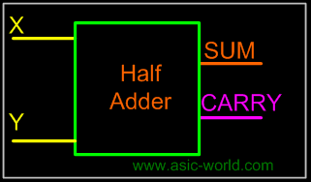

S (X,Y) = (1,2)
S = X'Y + XY'
S = XY
CARRY(X,Y) = (3)
CARRY = XY
Circuit

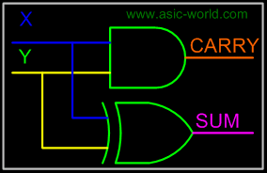

Full Adder

Full adder takes a three-bits input. Adding two single-bit binary values X, Y with a carry input bit C-in produces a sum bit S and a carry out C-out bit.

Truth Table

X | Y | Z | SUM | CARRY
0 | 0 | 0 | 0 | 0
0 | 0 | 1 | 1 | 0
0 | 1 | 0 | 1 | 0
0 | 1 | 1 | 0 | 1
1 | 0 | 0 | 1 | 0
1 | 0 | 1 | 0 | 1
1 | 1 | 0 | 0 | 1
1 | 1 | 1 | 1 | 1

SUM (X,Y,Z) = (1,2,4,7)
CARRY (X,Y,Z) = (3,5,6,7)

Kmap-SUM

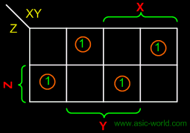

SUM = X'Y'Z + XY'Z' + X'YZ'
SUM = X Y Z

Kmap-CARRY

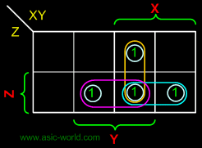
CARRY = XY + XZ + YZ

Full Adder using AND-OR
The below implementation shows implementing the full adder with AND-OR gates, instead of using XOR gates. The basis of the circuit below is from the above Kmap.
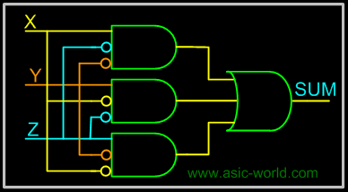

Circuit-CARRY

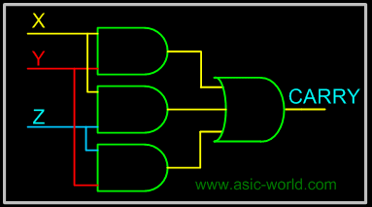

Full Adder using AND-OR

Circuit-SUM

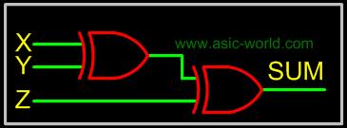

Circuit-CARRY

n-bit Carry Ripple Adder

An n-bit adder used to add two n-bit binary numbers can be built by connecting n full adders in series. Each full adder represents a bit position j (from 0 to n-1).

Each carry out C-out from a full adder at position j is connected to the carry in C-in of the full adder at higher position j+1. The output of a full adder at position j is given by:

Sj= Xj Yj Cj

Cj+1 = Xj . Yj + Xj . Cj + Y . Cj

In the expression of the sum Cj must be generated by the full adder at lower position j. The propagation delay in each full adder to produce the carry is equal to two gate delays = 2 D Since the generation of the sum requires the propagation of the carry from the lowest position to the highest position , the total propagation delay of the adder is approximately:

Total Propagation delay = 2 nD

4-bit Carry Ripple Adder

Adds two 4-bit numbers:
X = X3 X2 X1 X0
Y = Y3 Y2 Y1 Y0

producing the sum S = S3 S2 S1 S0 , C-out = C4 from the most significant position j=3

Total Propagation delay = 2 nD = 8D or 8 gate delays

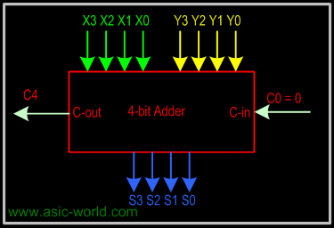

Larger Adder

Example: 16-bit adder using 4 4-bit adders. Adds two 16-bit inputs X (bits X0 to X15), Y (bits Y0 to Y15) producing a 16-bit Sum S (bits S0 to S15) and a carry out C16 from the most significant position.

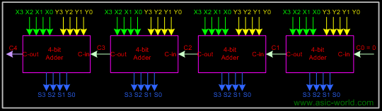

Propagation delay for 16-bit adder = 4 x propagation delay of 4-bit adder
= 4 x 2 nD = 4 x 8D = 32 D
or 32 gate delays

Carry Look-Ahead Adder

The delay generated by an N-bit adder is proportional to the length N of the two numbers X and Y that are added because the carry signals have to propagate from one full-adder to the next. For large values of N, the delay becomes unacceptably large so that a special solution needs to be adopted to accelerate the calculation of the carry bits. This solution involves a "look-ahead carry generator" which is a block that simultaneously calculates all the carry bits involved. Once these bits are available to the rest of the circuit, each individual three-bit addition (X_{i}+Y_{i}+carry-in_{i}) is implemented by a simple 3-input XOR gate. The design of the look-ahead carry generator involves two Boolean functions named Generate and Propagate. For each input bits pair these functions are defined as:

Gi = X_{i} . Y_{i}
Pi = X_{i} + Y_{i}

The carry bit c-out(i) generated when adding two bits Xi and Yi is '1' if the corresponding function Gi is '1' or if the c-out(i-1)='1' and the function Pi = '1' simultaneously. In the first case, the carry bit is activated by the local conditions (the values of Xi and Yi). In the second, the carry bit is received from the less significant elementary addition and is propagated further to the more significant elementary addition. Therefore, the carry_out bit corresponding to a pair of bits Xi and Yi is calculated according to the equation:

carry_out(i) = Gi + Pi.carry_in(i-1)

For a four-bit adder the carry-outs are calculated as follows

carry_out0 = G₀ + P₀ . carry_in₀
carry_out1 = G₁ + P₁ . carry_out₀ = G₁ + P₁G₀ + P₁P₀ . carry_in₀
carry_out2 = G₂ + P₂G₁ + P₂P₁G₀ + P₂P₁P₀ . carry_in₀
carry_out3 = G₃ + P₃G₂ + P₃P₂G₁ + P₃P₂P₁G₀ + P₃P₂P₁ . carry_in₀
The set of equations above are implemented by the circuit below and a complete adder with a look-ahead carry generator is next. The input signals need to propagate through a maximum of 4 logic gate in such an adder as opposed to 8 and 12 logic gates in its counterparts illustrated earlier.

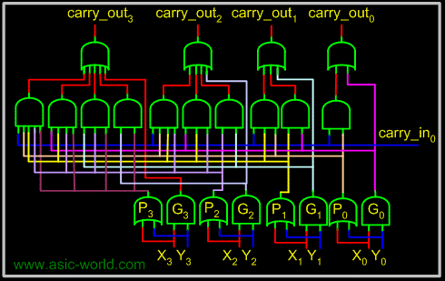

Sums can be calculated from the following equations, where carry_out is taken from the carry calculated in the above circuit.

sum_out₀ = X ₀ Y₀ carry_out₀
sum_out₁ = X ₁ Y₁ carry_out₁
sum_out₂ = X ₂ Y₂ carry_out₂
sum_out₃ = X ₃ Y₃ carry_out₃

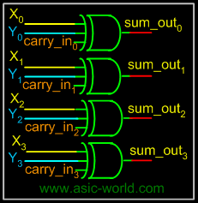

BCD Adder

BCD addition is the same as binary addition with a bit of variation: whenever a sum is greater than 1001, it is not a valid BCD number, so we add 0110 to it, to do the correction. This will produce a carry, which is added to the next BCD position.
- Add the two 4-bit BCD code inputs.
- Determine if the sum of this addition is greater than 1001; if yes, then add 0110 to this sum and generate a carry to the next decimal position.
Subtracter
Subtracter circuits take two binary numbers as input and subtract one binary number input from the other binary number input. Similar to adders, it gives out two outputs, difference and borrow (carry-in the case of Adder). There are two types of subtracters.
- Half Subtracter.
- Full Subtracter.
Half Subtracter
The half-subtracter is a combinational circuit which is used to perform subtraction of two bits. It has two inputs, X (minuend) and Y (subtrahend) and two outputs D (difference) and B (borrow). The logic symbol and truth table are shown below.
Symbol
Truth Table
X | Y | D | B
0 | 0 | 0 | 0
0 | 1 | 1 | 1
1 | 0 | 1 | 0
1 | 1 | 0 | 0
From the above table we can draw the Kmap as shown below for "difference" and "borrow". The boolean expression for the difference and Borrow can be written.
From the equation we can draw the half-subtracter as shown in the figure below.
Full Subtracter
A full subtracter is a combinational circuit that performs subtraction involving three bits, namely minuend, subtrahend, and borrow-in. The logic symbol and truth table are shown below.
Symbol
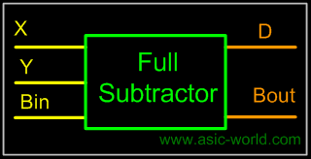
Truth Table
X | Y | Bin | D | Bout
0 | 0 | 0 | 0 | 0
0 | 0 | 1 | 1 | 1
0 | 1 | 0 | 1 | 1
0 | 1 | 1 | 0 | 1
1 | 0 | 0 | 1 | 0
1 | 0 | 1 | 0 | 0
1 | 1 | 0 | 0 | 0
1 | 1 | 1 | 1 | 1
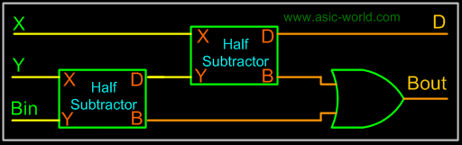
From above table we can draw the Kmap as shown below for "difference" and "borrow". The boolean expression for difference and borrow can be written.
D = X'Y'Bin + X'YBin' + XY'Bin' + XYBin
= (X'Y' + XY)Bin + (X'Y + XY')Bin'
= (X Y)'Bin + (X Y)Bin'
= X Y Bin
Bout = X'.Y + X'.Bin + Y.Bin
From the equation we can draw the half-subtracter as shown in figure below.
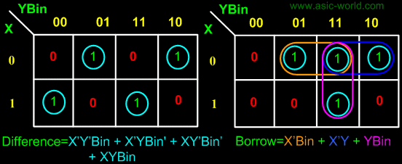
From the above expression, we can draw the circuit below. If you look carefully, you will see that a full-subtracter circuit is more or less same as a full-adder with slight modification.
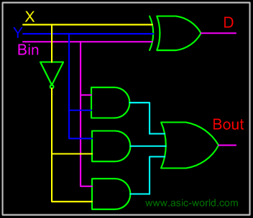
Parallel Binary Subtracter
Parallel binary subtracter can be implemented by cascading several full-subtracters. Implementation and associated problems are those of a parallel binary adder, seen before in parallel binary adder section.
Below is the block level representation of a 4-bit parallel binary subtracter, which subtracts 4-bit Y3Y2Y1Y0 from 4-bit X3X2X1X0. It has 4-bit difference output D3D2D1D0 with borrow output Bout.
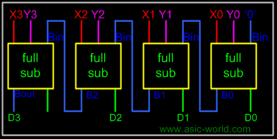
Serial Binary Subtracter
A serial subtracter can be obtained by converting the serial adder using the 2's complement system. The subtrahend is stored in the Y register and must be 2's complemented before it is added to the minuend stored in the X register.
The circuit for a 4-bit serial subtracter using full-adder is shown in the figure below.
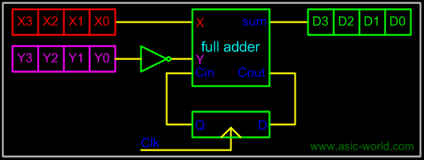
Comparators
Comparators can compare either a variable number X (xn xn-1 ... x3 x2 x1) with a predefined constant C (cn cn-1 ... c3 c2 c1) or two variable numbers X and Y. In the first case the implementation reduces to a series of cascaded AND and OR logic gates. If the comparator answers the question 'X>C?' then its hardware implementation is designed according to the following rules:
- The number X has two types of binary figures: bits corresponding to '1' in the predefined constant and bits corresponding to '0' in the predefined constant.
- The bits of the number X corresponding to '1' are supplied to AND gates
- The bits corresponding to '0' are supplied to OR logic gates
- If the least significant bits of the predefined constant are '10' then bit X0 is supplied to the same AND gate as bit X1.
If the least significant bits of the constant are all '1' then the corresponding bits of the number X are not included in the hardware implementation. All other relations between X and C can be transformed in equivalent ones that use the operator '>' and the NOT logic operator as shown in the table below.
Initial relationship to be tested | Equivalent relationship to be implemented
X&lt;C | NOT (X>C-1)
X<= C | NOT (X>C)
X >= C | X>C-1
The comparison process of two positive numbers X and Y is performed in a bit-by-bit manner starting with the most significant bit:
- If the most significant bits are Xn='1' and Yn='0' then number X is larger than Y.
- If Xn='0' and Yn='1' then number X is smaller than Y.
- If Xn=Yn then no decision can be taken about X and Y based only on these two bits.
If the most significant bits are equal then the result of the comparison is determined by the less significant bits Xn-1 and Yn-1. If these bits are equal as well, the process continues with the next pair of bits. If all bits are equal then the two numbers are equal.
Multipliers
Multiplication is achieved by adding a list of shifted multiplicands according to the digits of the multiplier. An n-bit X n-bit multiplier can be realized in combinational circuitry by using an array of n-1 n-bit adders where each adder is shifted by one position. For each adder one input is the shifted multiplicand multiplied by 0 or 1 (using AND gates) depending on the multiplier bit, the other input is n partial product bits.
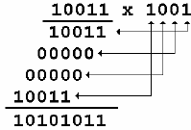

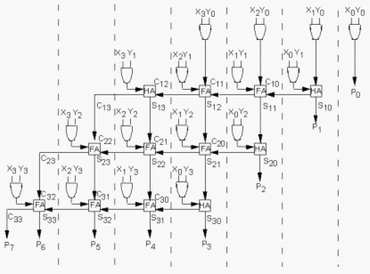

Dividers
The binary divisions are performed in a very similar manner to the decimal divisions, as shown in the below figure examples. Thus, the second number is repeatedly subtracted from the figures of the first number after being multiplied either with '1' or with '0'. The multiplication bit ('1' or '0') is selected for each subtraction step in such a manner that the subtraction result is not negative. The division result is composed from all the successive multiplication bits while the remainder is the result of the last subtraction step.
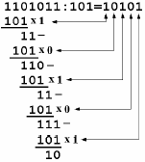
This algorithm can be implemented by a series of subtracters composed of modified elementary cells. Each subtracter calculates the difference between two input numbers, but if the result is negative the operation is canceled and replaced with a subtraction by zero. Thus, each divider cell has the normal inputs of a subtracter unit as in the figure below but a supplementary input ('div_bit') is also present. This input is connected to the b_req_out signal generated by the most significant cell of the subtracter. If this signal is '1', the initial subtraction result is negative and it has to be replaced with a subtraction by zero. Inside each divider cell the div_bit signal controls an equivalent 2:1 multiplexer that selects between bit 'x' and the bit included in the subtraction result X-Y. The complete division can therefore by implemented by a matrix of divider cells connected on rows and columns as shown in figure below. Each row performs one multiplication-and-subtraction cycle where the multiplication bit is supplied by the NOT logic gate at the end of each row. Therefor the NOT logic gates generate the bits of the division result.
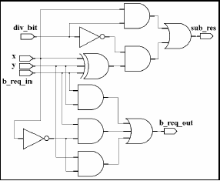
Parity Circuit
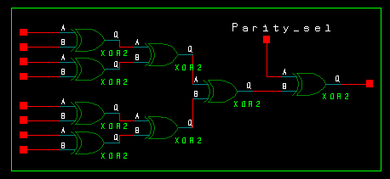
Sequential circuits
- Introduction
  - Asynchronous sequential circuit
  - Synchronous sequential circuits
- Concept of Sequential Logic
- Latches and Flip-Flops
  - RS Latch
  - RS Latch with Clock
  - Setup and Hold Time
  - D Latch
  - JK Latch
  - T Latch
  - JK Master Slave Flip-Flop
- Sequential Circuits Design
  - State Diagram
  - State Table
  - K-map
  - Circuit

Introduction

Digital electronics is classified into combinational logic and sequential logic. Combinational logic output depends on the inputs levels, whereas sequential logic output depends on stored levels and also the input levels.

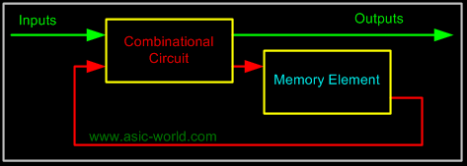

The memory elements are devices capable of storing binary info. The binary info stored in the memory elements at any given time defines the state of the sequential circuit. The input and the present state of the memory element determines the output. Memory elements next state is also a function of external inputs and present state. A sequential circuit is specified by a time sequence of inputs, outputs, and internal states.

There are two types of sequential circuits. Their classification depends on the timing of their signals:

- Synchronous sequential circuits
- Asynchronous sequential circuits
Asynchronous sequential circuit
This is a system whose outputs depend upon the order in which its input variables change and can be affected at any instant of time.
Gate-type asynchronous systems are basically combinational circuits with feedback paths. Because of the feedback among logic gates, the system may, at times, become unstable. Consequently they are not often used.
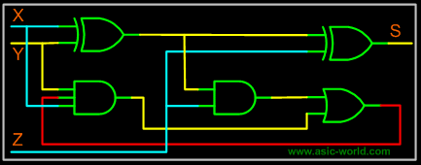
Synchronous sequential circuits
This type of system uses storage elements called flip-flops that are employed to change their binary value only at discrete instants of time. Synchronous sequential circuits use logic gates and flip-flop storage devices. Sequential circuits have a clock signal as one of their inputs. All state transitions in such circuits occur only when the clock value is either 0 or 1 or happen at the rising or falling edges of the clock depending on the type of memory elements used in the circuit. Synchronization is achieved by a timing device called a clock pulse generator. Clock pulses are distributed throughout the system in such a way that the flip-flops are affected only with the arrival of the synchronization pulse. Synchronous sequential circuits that use clock pulses in the inputs are called clocked-sequential circuits. They are stable and their timing can easily be broken down into independent discrete steps, each of which is considered separately.
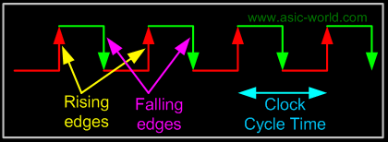
A clock signal is a periodic square wave that indefinitely switches from 0 to 1 and from 1 to 0 at fixed intervals. Clock cycle time or clock period: the time interval between two consecutive rising or falling edges of the clock.

Clock Frequency = 1 / clock cycle time (measured in cycles per second or Hz)
Example:Clock cycle time = 10ns clock frequency = 100Mhz

Concept of Sequential Logic

A sequential circuit as seen in the last page, is combinational logic with some feedback to maintain its current value, like a memory cell. To understand the basics let's consider the basic feedback logic circuit below, which is a simple NOT gate whose output is connected to its input. The effect is that output oscillates between HIGH and LOW (i.e. 1 and 0). Oscillation frequency depends on gate delay and wire delay. Assuming a wire delay of 0 and a gate delay of 10ns, then oscillation frequency would be (on time + off time = 20ns) 50Mhz.

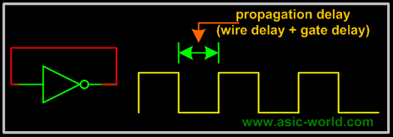

The basic idea of having the feedback is to store the value or hold the value, but in the above circuit, output keeps toggling. We can overcome this problem with the circuit below, which is basically cascading two inverters, so that the feedback is in-phase, thus avoids toggling. The equivalent circuit is the same as having a buffer with its output connected to its input.

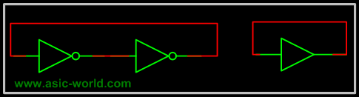

But there is a problem here too: each gate output value is stable, but what will it be? Or in other words buffer output can not be known. There is no way to tell. If we could know or set the value we would have a simple 1-bit storage/memory element.
The circuit below is the same as the inverters connected back to back with provision to set the state of each gate (NOR gate with both inputs shorted is like a inverter). I am not going to explain the operation, as it is clear from the truth table. S is called set and R is called Reset.
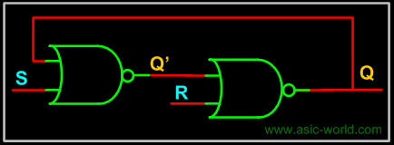

S | R | Q | Q+
0 | 0 | 0 | 0
0 | 0 | 1 | 1
0 | 1 | X | 0
1 | 0 | X | 1
1 | 1 | X | 0

There still seems to be some problem with the above configuration, we can not control when the input should be sampled, in other words there is no enable signal to control when the input is sampled. Normally input enable signals can be of two types.

- Level Sensitive or ( LATCH)
- Edge Sensitive or (Flip-Flop)
Level Sensitive: The circuit below is a modification of the above one to have level sensitive enable input. Enable, when LOW, masks the input S and R. When HIGH, presents S and R to the sequential logic input (the above circuit two NOR Gates). Thus Enable, when HIGH, transfers input S and R to the sequential cell transparently, so this kind of sequential circuits are called transparent Latch. The memory element we get is an RS Latch with active high Enable.
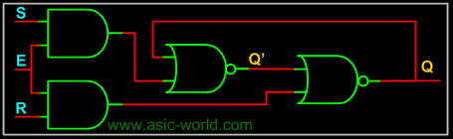
Edge Sensitive: The circuit below is a cascade of two level sensitive memory elements, with a phase shift in the enable input between first memory element and second memory element. The first RS latch (i.e. the first memory element) will be enabled when CLK input is HIGH and the second RS latch will be enabled when CLK is LOW. The net effect is input RS is moved to Q and Q' when CLK changes state from HIGH to LOW, this HIGH to LOW transition is called falling edge. So the Edge Sensitive element we get is called negative edge RS flip-flop.

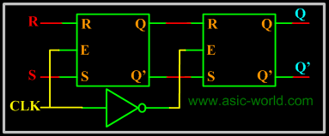
Now that we know the sequential circuits basics, let's look at each of them in detail in accordance to what is taught in colleges. You are always welcome to suggest if this can be written better in any way.

Latches and Flip-Flops

There are two types types of sequential circuits.
- Asynchronous Circuits.
- Synchronous Circuits.
As seen in last section, Latches and Flip-flops are one and the same with a slight variation: Latches have level sensitive control signal input and Flip-flops have edge sensitive control signal input. Flip-flops and latches which use this control signals are called synchronous circuits. So if they don't use clock inputs, then they are called asynchronous circuits.
RS Latch
RS latch have two inputs, S and R. S is called set and R is called reset. The S input is used to produce HIGH on Q ( i.e. store binary 1 in flip-flop). The R input is used to produce LOW on Q (i.e. store binary 0 in flip-flop). Q' is Q complementary output, so it always holds the opposite value of Q. The output of the S-R latch depends on current as well as previous inputs or state, and its state (value stored) can change as soon as its inputs change. The circuit and the truth table of RS latch is shown below. (This circuit is as we saw in the last page, but arranged to look beautiful :-) ).
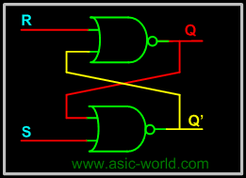
S | R | Q | Q+
0 | 0 | 0 | 0
0 | 0 | 1 | 1
0 | 1 | X | 0
1 | 0 | X | 1
1 | 1 | X | 0
The operation has to be analyzed with the 4 inputs combinations together with the 2 possible previous states.
- When S = 0 and R = 0: If we assume Q = 1 and Q' = 0 as initial condition, then output Q after input is applied would be Q = (R + Q')' = 1 and Q' = (S + Q)' = 0. Assuming Q = 0 and Q' = 1 as initial condition, then output Q after the input applied would be Q = (R + Q')' = 0 and Q' = (S + Q)' = 1. So it is clear that when both S and R inputs are LOW, the output is retained as before the application of inputs. (i.e. there is no state change).
- When S = 1 and R = 0: If we assume Q = 1 and Q' = 0 as initial condition, then output Q after input is applied would be Q = (R + Q')' = 1 and Q' = (S + Q)' = 0. Assuming Q = 0 and Q' = 1 as initial condition, then output Q after the input applied would be Q = (R + Q')' = 1 and Q' = (S + Q)' = 0. So in simple words when S is HIGH and R is LOW, output Q is HIGH.
- When S = 0 and R = 1: If we assume Q = 1 and Q' = 0 as initial condition, then output Q after input is applied would be Q = (R + Q')' = 0 and Q' = (S + Q)' = 1. Assuming Q = 0 and Q' = 1 as initial condition, then output Q after the input applied would be Q = (R + Q')' = 0 and Q' = (S + Q)' = 1. So in simple words when S is LOW and R is HIGH, output Q is LOW.
- When S = 1 and R =1 : No matter what state Q and Q' are in, application of 1 at input of NOR gate always results in 0 at output of NOR gate, which results in both Q and Q' set to LOW (i.e. Q = Q'). LOW in both the outputs basically is wrong, so this case is invalid.
The waveform below shows the operation of NOR gates based RS Latch.
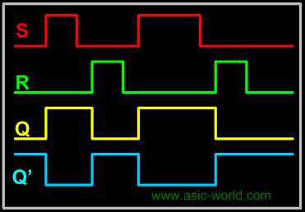
It is possible to construct the RS latch using NAND gates (of course as seen in Logic gates section). The only difference is that NAND is NOR gate dual form (Did I say that in Logic gates section?). So in this case the R = 0 and S = 0 case becomes the invalid case. The circuit and Truth table of RS latch using NAND is shown below.
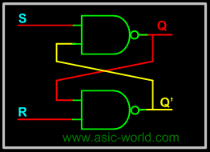

S | R | Q | Q+
1 | 1 | 0 | 0
1 | 1 | 1 | 1
0 | 1 | X | 0
1 | 0 | X | 1
0 | 0 | X | 1

If you look closely, there is no control signal (i.e. no clock and no enable), so this kind of latches or flip-flops are called asynchronous logic elements. Since all the sequential circuits are built around the RS latch, we will concentrate on synchronous circuits and not on asynchronous circuits.

RS Latch with Clock

We have seen this circuit earlier with two possible input configurations: one with level sensitive input and one with edge sensitive input. The circuit below shows the level sensitive RS latch. Control signal "Enable" E is used to gate the input S and R to the RS Latch. When Enable E is HIGH, both the AND gates act as buffers and thus R and S appears at the RS latch input and it functions like a normal RS latch. When Enable E is LOW, it drives LOW to both inputs of RS latch. As we saw in previous page, when both inputs of a NOR latch are low, values are retained (i.e. the output does not change).

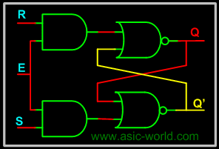

Setup and Hold Time

For synchronous flip-flops, we have special requirements for the inputs with respect to clock signal input. They are

- Setup Time: Minimum time period during which data must be stable before the clock makes a valid transition. For example, for a posedge triggered flip-flop, with a setup time of 2 ns, Input Data (i.e. R and S in the case of RS flip-flop) should be stable for at least 2 ns before clock makes transition from 0 to 1.
- Hold Time: Minimum time period during which data must be stable after the clock has made a valid transition. For example, for a posedge triggered flip-flop, with a hold time of 1 ns. Input Data (i.e. R and S in the case of RS flip-flop) should be stable for at least 1 ns after clock has made transition from 0 to 1.
If data makes transition within this setup window and before the hold window, then the flip-flop output is not predictable, and flip-flop enters what is known as meta stable state. In this state flip-flop output oscillates between 0 and 1. It takes some time for the flip-flop to settle down. The whole process is called metastability. You could refer to tidbits section to know more information on this topic.
The waveform below shows input S (R is not shown), and CLK and output Q (Q' is not shown) for a SR posedge flip-flop.
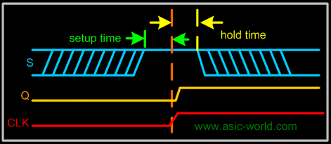
D Latch

The RS latch seen earlier contains ambiguous state; to eliminate this condition we can ensure that S and R are never equal. This is done by connecting S and R together with an inverter. Thus we have D Latch: the same as the RS latch, with the only difference that there is only one input, instead of two (R and S). This input is called D or Data input. D latch is called D transparent latch for the reasons explained earlier. Delay flip-flop or delay latch is another name used. Below is the truth table and circuit of D latch.

In real world designs (ASIC/FPGA Designs) only D latches/Flip-Flops are used.
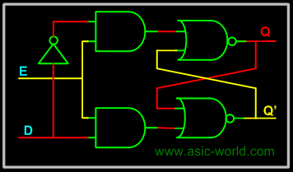

D | Q | Q+
1 | X | 1
0 | X | 0

Below is the D latch waveform, which is similar to the RS latch one, but with R removed.

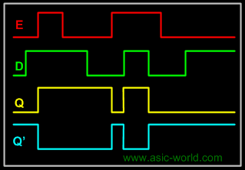

JK Latch

The ambiguous state output in the RS latch was eliminated in the D latch by joining the inputs with an inverter. But the D latch has a single input. JK latch is similar to RS latch in that it has 2 inputs J and K as shown figure below. The ambiguous state has been eliminated here: when both inputs are high, output toggles. The only difference we see here is output feedback to inputs, which is not there in the RS latch.

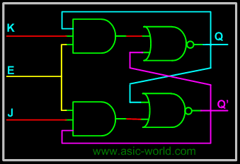

J | K | Q
1 | 1 | 0
1 | 1 | 1
1 | 0 | 1
0 | 1 | 0
T Latch
When the two inputs of JK latch are shorted, a T Latch is formed. It is called T latch as, when input is held HIGH, output toggles.
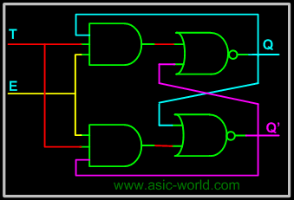
T | Q | Q+
1 | 0 | 1
1 | 1 | 0
0 | 1 | 1
0 | 0 | 0

JK Master Slave Flip-Flop
All sequential circuits that we have seen in the last few pages have a problem (All level sensitive sequential circuits have this problem). Before the enable input changes state from HIGH to LOW (assuming HIGH is ON and LOW is OFF state), if inputs changes, then another state transition occurs for the same enable pulse. This sort of multiple transition problem is called racing.
If we make the sequential element sensitive to edges, instead of levels, we can overcome this problem, as input is evaluated only during enable/clock edges.
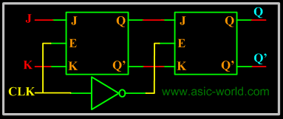
In the figure above there are two latches, the first latch on the left is called master latch and the one on the right is called slave latch. Master latch is positively clocked and slave latch is negatively clocked.
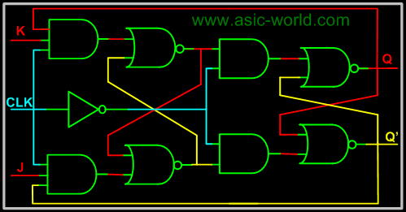
Sequential Circuits Design
We saw in the combinational circuits section how to design a combinational circuit from the given problem. We convert the problem into a truth table, then draw K-map for the truth table, and then finally draw the gate level circuit for the problem. Similarly we have a flow for the sequential circuit design. The steps are given below.
- Draw state diagram.
- Draw the state table (excitation table) for each output.
- Draw the K-map for each output.
- Draw the circuit.
Looks like sequential circuit design flow is very much the same as for combinational circuit.
State Diagram
The state diagram is constructed using all the states of the sequential circuit in question. It builds up the relationship between various states and also shows how inputs affect the states.
To ease the following of the tutorial, let's consider designing the 2 bit up counter (Binary counter is one which counts a binary sequence) using the T flip-flop.
Below is the state diagram of the 2-bit binary counter.
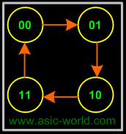
State Table
The state table is the same as the excitation table of a flip-flop, i.e. what inputs need to be applied to get the required output. In other words this table gives the inputs required to produce the specific outputs.
Q1 | Q0 | Q1+ | Q0+ | T1 | T0
0 | 0 | 0 | 1 | 0 | 1
0 | 1 | 1 | 0 | 1 | 1
1 | 0 | 1 | 1 | 0 | 1
1 | 1 | 0 | 0 | 1 | 1

K-map
The K-map is the same as the combinational circuits K-map. Only difference: we draw K-map for the inputs i.e. T1 and T0 in the above table. From the table we deduct that we don't need to draw K-map for T0, as it is high for all the state combinations. But for T1 we need to draw the K-map as shown below, using SOP.
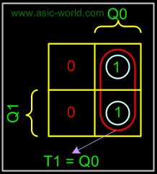
Circuit
There is nothing special in drawing the circuit, it is the same as any circuit drawing from K-map output. Below is the circuit of 2-bit up counter using the T flip-flop.
